11-1、Rotary Encoder EC11

1. 参考《0-1》文档，插入ESP32模块。
2. 用导线连接IO口与EC11接口，如下图所示：

蓝色线<------->ROTARY_A

红色线<------->ROTARY_B

绿色线<------->ROTARY_BTN

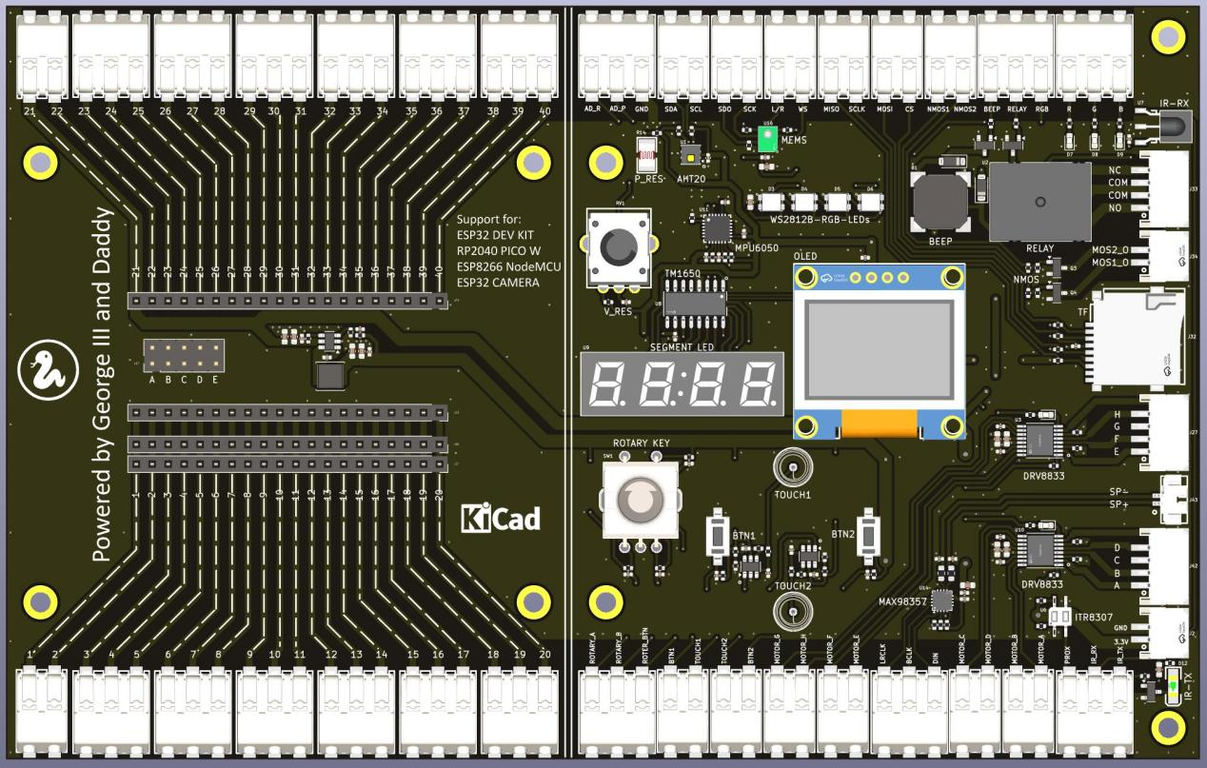

1. 代码示例

#main.py

import time

import difiot_EC11

#this program is for esp8266 or esp32, with inquiry method

#EC11 pin and pos config

#ec11 = difiot_EC11.EC11(13, 10, 15, 2) #for esp8266

ec11 = difiot_EC11.EC11(16, 17, 5, 2) #for esp32

dict_ec11 = {"pos": 0, "time": 0}

while True:

#read current pos and last action time (us). If the position is unchanged, the read time is 0

ec11.readPos(dict_ec11)

if (dict_ec11["pos"] > 10) or (dict_ec11["pos"] < -10):

ec11.setPos(0) #set pos

dict_ec11["pos"]

print ("pos = %d" %dict_ec11["pos"])

print ("last action time(us) = %d" %dict_ec11["time"])

keyStatus = ec11.readKey()

print ("key status = %d" %keyStatus)

time.sleep(0.5)

1. 上传main.py和difiot_EC11.py文件到模块中，按F5或点击运行按钮，然后旋转或按下旋转编码器，通过输出信息可以看出旋转的速度、旋转的方向、是否按下。

